# PROBLEM SOLVING- **PRACTICE S6**

# Instructions

* Three of the words will be in the same classification; **the remaining one will not be.**
* Your answer will be the one word that **does NOT belong** in the same classification as the others.

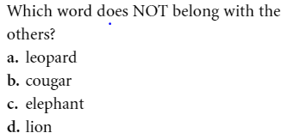

**Q1 –** Define the steps to solve this problem

|  |  |
| --- | --- |
| **Define**what is the problem, what is the expected work |  |
| **Find**a strategy |  |
| **Implement**the strategy |
| **Review**, test, and if it does not work, change your strategy |  |

**Q2 –** Apply this strategy to solve the following 3 other problems

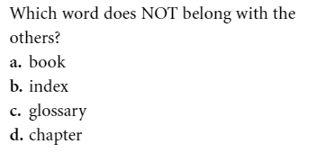

|  |  |
| --- | --- |
| **Implement**the strategy |  |

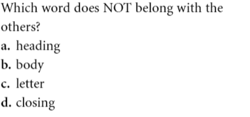

|  |  |
| --- | --- |
| **Implement**the strategy |  |

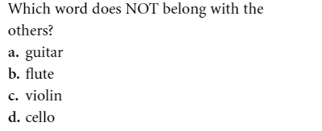

|  |  |
| --- | --- |
| **Implement**the strategy |  |